
Button Battery Compliance- Retail
Attention Retailer,
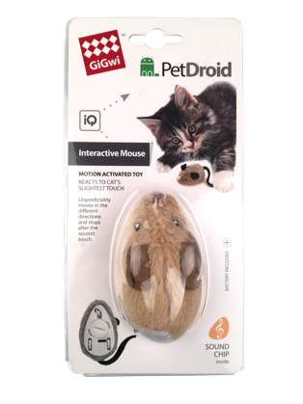
From the recent changes to the new button battery laws released in Australia on June 22nd 2022, and investigation it has come to our attention that the below item is not compliant with the mandatory safety standard.

SKU code: DAG2405
Barcode: 846295070669
Name: GiGwi Pet Droid Mouse

As a result this product is being recalled from the Australian market.
Defect: The product does not comply The battery compartment does not contain a captive screw designed to ensure the compartment is resistant to being opened by children.
Hazard: If young children gain access to button batteries and ingest them, they are likely to suffer severe internal burn injuries, which can result in serious injury or death. Button batteries also pose a choking hazard to young children.
What to do: Please remove all product from your shelves and keep in a safe place out of reach of children. Please contact your wholesale partner who supplied the product to organise a refund.
Please also display the consumer product recall notice in your store.
For further information please email info@gigwiaustralia.com.au

Many thanks
GiGwi Australia

Email: info@gigwiaustralia.com.au
www.gigwi.com.au



