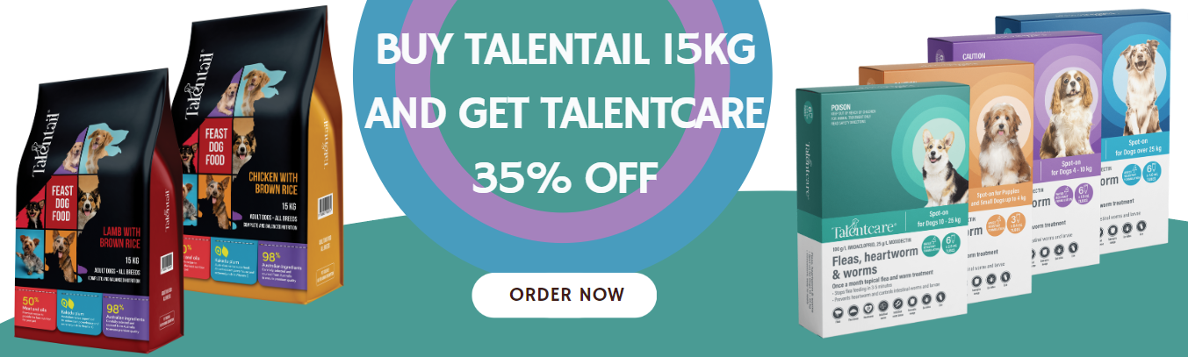

Stock Code | Description | Total Stock
DPT5000 | TALENTAIL CHICK BRN RICE ADULT DOGS 15KG
DPT5020 | TALENTAIL LAMB BRN RICE ADULT DOGS 15KG

Stock Code | Description | Total Stock
CHT2000 | TALENTCARE CAT SPOTON UP TO 4KG 6 PACK
CHT2010 | TALENTCARE CAT SPOTON OVER 4KG 6 PACK
DHT3000 | TALENTCARE PUP SML DOG UP TO 4KG 3 PACK
DHT3010 | TALENTCARE SPOTON DOG 4-10KG 6 PACK
DHT3020 | TALENTCARE SPOTON DOG 10-25KG 6 PACK
DHT3030 | TALENTCARE SPOTON DOG OVER 25KG 6 PACK

Account/Store Name: |  | Phone: | Fax:
Contact Name: |  | Email:
Address:
Suburb:
State: | Postcode: | To be added to next order | To be delivered separately

